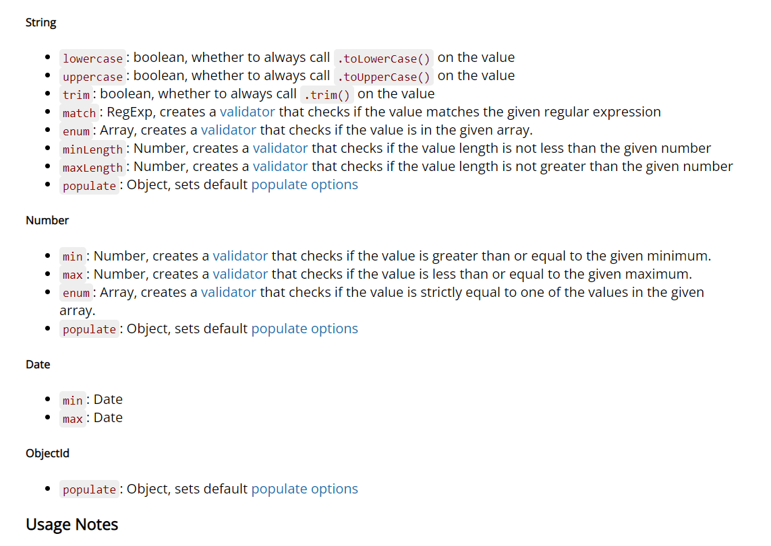

Now we will discuss type of validations   
like in a schema if we want to fix one thing like this thing is required then we can write like this

name : {type : String , required : true},

ishe tarike se name ka aana fix h warna wo error throw kar dega  
iske alwaa jab type string ho tho minlength and maxlength jaise validator bhi aa jaate h

(see in above image)

One thing which I want to tell   
  
enum validator   
read about that

Prefer this link :

<https://mongoosejs.com/docs/validation.html>

name : {

type : String ,

required : true,

enum : [“Pankaj”, “Rakesh”, “Pinku”]

},

Yeh validation yeh kaam karta h ki jo values aane wali h wo inhe array mai hi honi chaaiye otherwise error throw kar dega

Yeh real life mai kaam aa Sakata h kaise like tum ek jan se kuch service le rhe ho aur uske pass only 3 service h jaise wo c , c++ and java pada Sakata h tho tum wha par python from mai fill nahi kar paaygoee  
means wo theen mai se hi choose karna jaruri h

Read about more in mongoose docs

<https://mongoosejs.com/docs/validation.html>  
<https://mongoosejs.com/docs/schematypes.html>

written by : Pankaj saini